
July 2011 Volume V, No. 3
Among Friends

 | There is no way to quantify the benefit the library and consequently the community have received through Friends’ advocacy and fundraising efforts. After all, we know that this location’s very existence can be directly
attributed to public demand and your campaign to bring a library branch to Squirrel Hill.

Now almost 40 years later it is up to the community once again to secure the future of our city’s libraries. It will take just as much effort, but the benefits are just as great if not greater. The library is pursuing six strategies for sustainable operating funding (see page 3), but the one with the most potential for immediate and substantial payoff is the fifth strategy, the voter initiative we’re calling “Our Library, Our Future”.

Every friend of the library should be signed up to volunteer for the Our Library, Our Future campaign. Gathering petitions, throwing house parties, recruiting your friends and neighbors, donating to the campaign; any and all efforts you can make have the potential for raising over $3 million per year for the library’s
operations. That is a HUGE return on investment that far exceeds anything we’ll ever be able to do through book sales or fundraising. If you’ve yet to get involved or can do more, please contact the campaign at ourlibraryourfuture@gmail.com. For more information please go to the voter initiative website, www.OurlibraryOurfuture.org. – Holly McCullough, Manager, CLP—Squirrel Hill | 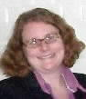

Summer is upon us and we are busily beautifying our homes and communities by gardening, but autumn will be upon us before we know it.  Soon it will be November, when we will have the opportunity to keep our communities reading by voting YES on a referendum for a ¼ mill increase in the real estate tax, to provide permanent, reliable funding for our nineteen Pittsburgh Carnegie Libraries. A mill is a tenth of a penny, so the added tax would be 25¢ on each $1,000 of the assessment on a property. This is only $25 on a home assessed at $100,000!  “Our Library, Our Future” is the campaign to pass this referendum. As of June 26 the library had gotten over 2,500 signatures on a petition to put the referendum on November’s ballot. We are aiming for 10,000, so we are far from done with this first stage of gathering signatures. This and stage two, getting out the vote in November, are projects that all of our Friends groups and individuals can work on; we encourage you to participate and show solidarity for this measure. Every action you take on this vote, no matter how small, will have an impact on the outcome.  “Democracy cannot succeed unless those who express their choice are prepared to choose wisely.” Franklin Delano Roosevelt  short saying?? or I can rearrange the MEETINGS and have a larger sayings box below your message |  | WELCOME, NEW MEMBERS  Join us at our regular  Friends Meetings:    Saturday July 9 at 10 am  Saturday Sept 3 at 10 am  Saturday O ct 1 at 10 am  Saturday July 9 at 10 a.m.  Saturday Sept 3 at 10 a.m.
  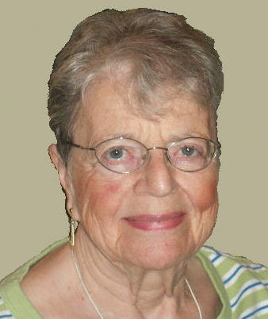 | PRESIDENT’S MESSAGE  by Joan Schwartzman  “If you have a garden and a library, you have everything you need.” Marcus Tullius Cicero
  Alexandra Abovyan  SunHee Baek  Baka Eisenberg-Cohen  Jeralyn Beach  Hana El-Ghali  Barbara Granito  Jay Lampert  Deanna Maag  Matthew Moore  Janice Myers  Betsy Peitz  Elian Rosenfeld | Melissa Rychener  Sara Segel  Rabbi Terri Smith  Anand Sooriamurthi  Frank Stencil  Timothy Stienstraw  Brittany Story  Joel Tarr  Elizabeth Thomas  John Voytko  Gail Wolfe

Published by the Friends of the Squirrel Hill Library, 5801 Forbes Avenue, Pittsburgh, PA 15217
website: www.carnegielibrary.org/locations/squirrelhill e-mail: friends@pittsburghusedbooks.com
editor: Joan Schwartzman mailing list: Allison Marciszyn production: Dean Damick, Marion Damick, Rita Motor, Margie Spenser, Serena Spenser

..

July 2011 | Among Friends | Volume V, No. 3

  This year the Summer Reading Club theme, One World, Many Stories, celebrates cultures across the  globe. Come into the library or go to www.carnegielibrary.org/summer and sign up your child for Summer  Reading Club! We have two types of programs for children: | Children’s Department Summer Happenings  by Megan Fogt, Manager of Children's Services | 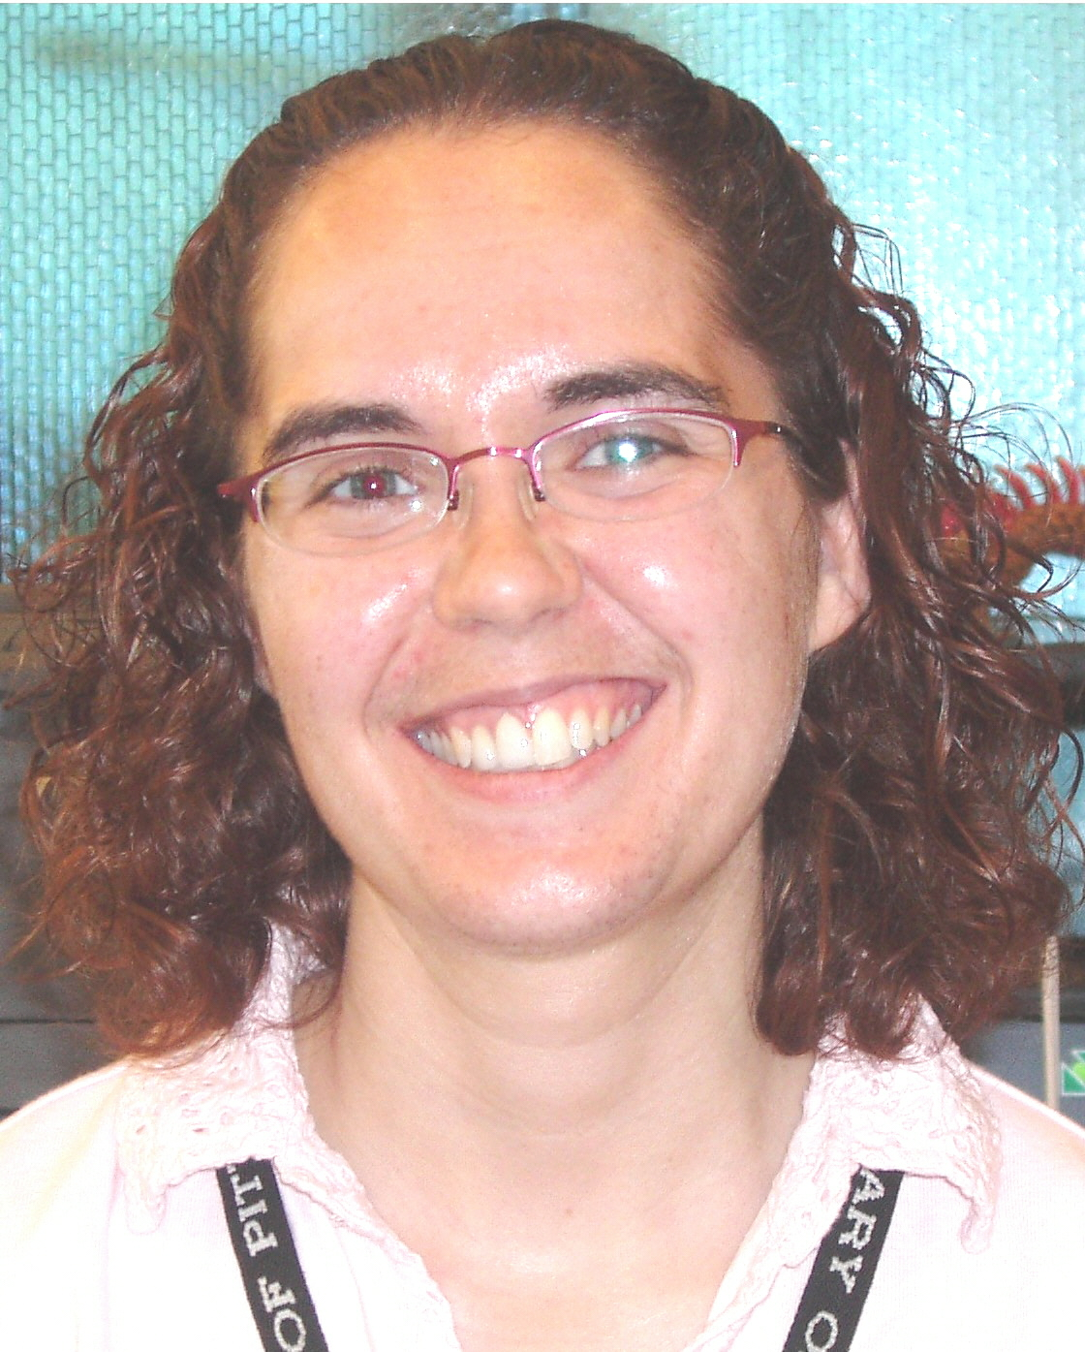

- Our Read-to-Me program is for young children who have books read to them. Celebrate the fun of reading to your child, while providing them with the six early literacy skills that research suggests all children need to have to become strong readers.
- Our Readers program is for children reading on their own. Research suggests that students who read at least six books over the summer maintain their reading skills, while reading more than six books leads to gains in reading skills.
Both our Read-to-Me and Reader programs feature our “Around the World in 63 Days!” game. Children are encouraged to read throughout the summer and earn stickers, prizes, and a chance to win the grand prize in our end-of-summer drawing.

In addition to our Summer Reading Club program, we have a variety of fun events for children and their families. These include:

Our Weekly Storytimes:

- Pre-K Storytime (3-5 yrs. old)
Mondays at 1:00 PM

- Family Storytime (all ages welcome)
Saturdays at 11:00 AM

- Terrific Tales for Toddlers (18 mo. – 3 yrs. old)
Tuesdays at 10:30 AM and 11:30 AM

- Baby & Me (birth – 18 mo.)
Thursdays at 10:30 AM and 11:30 AM School-age Craft Club
(5 – 12 yrs. old), Wednesdays at 4:00 PM
It's a good thing when children enjoy books,isn't it?
Judy Blume
Please register by calling 412-422-9841
or emailing sqhillchildrens@carnegielibrary.org

- June 22nd – Papermaking

- June 29th – Worry Dolls

- July 6th – Button Making

- July 13th – Fairy and Gnome Houses

- July 20th – Key Chains

- July 27th – Quilt Making

- August 3rd – Tie Dye

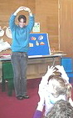
Miss Erin Says Goodbye
I wanted to take this opportunity to say goodbye to all of the friends that I’ve met and grown so fond of during my 11 years of working at CLP-Squirrel Hill. I have really enjoyed my time at Squirrel Hill as a Library Assistant in both the Reference and Children’s areas. I will be leaving Squirrel Hill to become the Children and Teen Librarian at CLP-Brookline. I’m looking forward to meeting new friends of all ages, and getting to know a new community and library. Even though Brookline is over the river and through the mountain from Squirrel Hill, it’s only about ten miles away. So please stop by and visit me, especially if you ever find yourself in the South Hills area. I’m sorry I didn’t get a chance to say goodbye to everyone in person. Please email me @ sciolie@carnegielibrary.org Best wishes! – Erin “Miss Erin” Scioli Erin “Miss Erin” Scioli

July 2011 Among Friends Volume V, No. 3
  Mark Russell,  Librarian | Fiction,  and Fun | Third Thursday of the month from 1 to 4  July 21  Hamlet by William Shakespeare  August 18  The Namesake by Jhumpa Lahiri  September 15  Othello by William Shakespeare |   Jeanne Bergad  Moderator
  Film, | 

Film, Fiction, and Fun is a special series presented at the Carnegie Library of Pittsburgh – Squirrel Hill that explores the relationship between films and the novels that inspired them. Attendees are encouraged to read a monthly fiction selection, then join CCAC’s Jeanne Bergad for a screening of the film and discussion to follow.  July 21st’s title is Hamlet, by William Shakespeare. Believed to be written between 1599 and 1601, this tragedy is one of the most-performed plays of all time. Hamlet tells the tale of a prince who discovers that his father, the former king of Denmark, was murdered by Claudius, the current king and Hamlet’s uncle. Hamlet sets upon the path towards revenge, encountering love, madness, suicide, and betrayal along the way. Many film versions of Hamlet have been filmed, with the title role played by a multitude of actors, including Laurence Olivier, Richard Burton, Mel Gibson, and Kenneth Branagh. In the year 2000, a modernized version of Hamlet was created that added Ethan Hawke to this esteemed group. Twenty-nine years old at the time of filming, Hawke was the youngest actor yet to play the troubled protagonist in a movie. The film was set in 20th century New York, with the kingdom of Denmark replaced by the Denmark Corporation. Alongside Hawke, the film starred Bill Murray, Julia Stiles, Kyle MacLachlan, Diane Venora, Sam Shepard, and Liev Schreiber.  August 18th’s book is The Namesake, by Jhumpa Lahiri. Originally a novella published in The New Yorker, it was later released in 2003 as Lahiri’s second novel. The central character in The Namesake is Gogol, the American-born son of Bengali immigrants Ashimi and Ashoke. In his education, career, and romantic relationships, Gogol struggles to find a balance between his Bengali heritage and American nationality. The 2006 film adaptation of The Namesake was directed by Mira Nair and starred Kal Penn in the role of Gogol. For some of the film’s party and funeral scenes, Nair cast Jhumpa Lahiri and her family as extras.  September 15th’s selection is Othello, by William Shakespeare. One of Shakespeare’s most famous tragedies, Othello follows the story of the title character, a Moorish general in the Venetian army, as his life is systematically destroyed by Iago, a jealous subordinate. The 1995 screen adaptation of Othello was director Oliver Parker’s first film. It starred Laurence Fishburne as Othello, Kenneth Branagh as Iago, and Irene Jacob as Othello’s wife, Desdemona. Fishburne holds the distinction of being the first African-American to play Othello in a film; prior movie Othellos Laurence Oliver and Orson Welles donned dark makeup to play the Moorish hero. | Some people drink from the Fountain of Knowledge; others just gargle.  Dr. Robert Anthony
 | 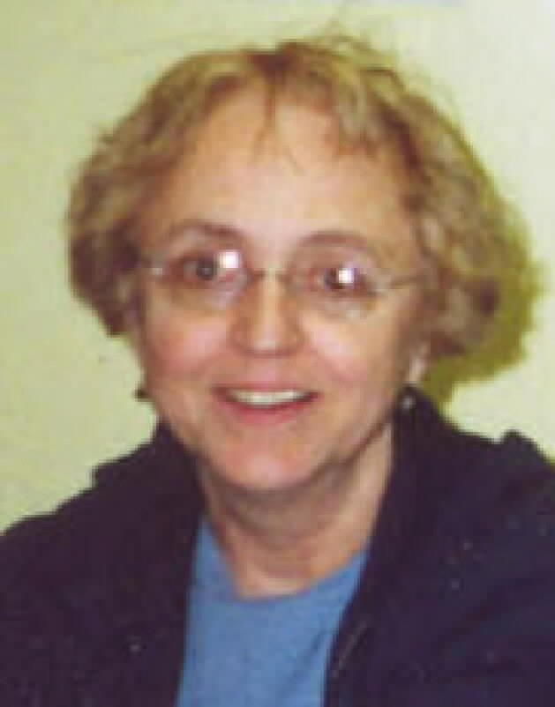 | MINI SALE NEWS  by Pat Bender,  mini-sale chair  Since the February mini
sale ended, a new effort has been launched to organize the book room and maintain a high level of order.
Some new volunteers and some old
hands are participating in this project. id

D.J. is a retired science librarian who daily converts chaos into order by sorting donations and stocking shelves. Shannon Gotsick has adopted the ongoing sale shelves. She is an interior designer currently on hiatus with her young family. She arranges the ongoing sale shelves and is working on a system of marking new additions and rotating out the books that have been for sale the longest. Jude Goldstein, a professional organizer, comes in on Thursday afternoons. She will be a great help during set-ups and doing regular displays. Our mentor Joan Cooper, also a retired librarian, is busy maintaining the overall quality of our offerings by weeding out the outdated
material. Dean Damick is always willing to do whatever needs to be done. I'm there too. We have fun and we are willing to share. Drop in at the
Friends' book room or email oursounds @msn.com.
Currently, we are gearing up for the July Sidewalk Sale. There will be a boutique featuring new jewelry, vintage items, and a wide assortment of hand knits.

By September, I will be ready for another mini sale! (See page 6.)
"Let's Speak English" --From June through August 2011, non-native speakers of English will have a free opportunity to practice their conversational skills during weekly "Let's Speak English" sessions. The group, which will be led by a former ESL teacher, will meet in Meeting Room C from 6-7 pm every Tuesday. Registration is not required.
July 2011 Among Friends Volume V, No. 3

 | NAMM BUSINESS CENTER PROGRAMS  July – September 2011  by Dorothy Kabakeris, Namm Business Center Librarian  All programs are scheduled for Wednesday  from 10:15 AM-11:00 AM  July 20 Find free answers to legal questions
  
Find free authoritative answers to many personal and business legal questions on the Internet and
at the Allegheny County Law Library.
Presented by Joel Fishman, Ph.D., Assistant Director, Allegheny County Law Library.
August NO PROGRAMS

Sept 14 Sales Are the Heart of a Business
But there is an art to converting sales leads into customers. Get ideas on deriving the most of every opportunity from finding leads to warming up cold leads. Discover the value of a pre-call plan and how to manage expectations. This seminar should help you develop your own formula for sales success.
Presented by Timothy Sullivan, Pittsburgh Business Times
Sept 21 Learn the Surprising Secrets of Low Cost Marketing.
Hear how to make your product or service irresistible to customers without lowering the price. Invigorate your business with key strategies in developing and increasing the value of your brand.
Presented by Dan Droz, president of Droz and Associates. Mr. Droz is a former adjunct professor of Design Management at CMU. In 1996 he was recognized as one of seven distinguished alumni at the 25th anniversary of the Carpenter Center for the Visual Arts at his alma mater, Harvard University.

 | Special Book Talk:  Tuesday, July 26, 2011 @ 1:00 PM  Pittsburgh Noir, an anthology of 14 new mystery and thriller short stories set in Pittsburgh, will be presented by award-winning local authors Nancy Martin, Tom Lipinski, and Kathleen George (who also edited). Other esteemed contributors to this collection include Stewart O'Nan, Hilary Masters, and Reginald McKnight. The stories roar forth, showing the true underbelly of “the most livable city in America”. Each story is set in a different neighborhood, from Forest Hills, the Mexican War Streets, Schenley Farms, Carrick, McKees Rocks, Wilkinsburg, and Fox Chapel to Highland Park, Homewood, Morningside, Lawrenceville, Bloomfield, East Liberty, and Squirrel |   George  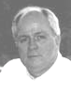  Lipinski
Hill. These are the fictional stories of the fear and guilt and rebellion and denial in regular people: the man grilling hot dogs, the woman buying groceries. Their secret lives…  There will be a book signing following the talk.  [Check out this newspaper article quoting several of the authors about just how “noir” Pittsburgh is: http://www.yourpennhills.com/pennhillsprogress/article/city-neighborhoods-provide-perfect-settings-noir-series.] |  |   Martin

The Squirrel Hill  Adult Book Discussion Group  meets on Thursday  from 1:00 pm to 2:00 pm  All are Welcome.  July 28  Ava’s Man by Rick Bragg, 2001  August – no meeting  Sept 22  Shadow Divers: the true adventure of two Americans who risked everything to solve one of the last mysteries of World War II  by Robert Kurson, 2004. | Art at the Squirrel Hill Library    Coming up are:  July: Jim Smith – mixed media  August: Jay Lipp – acrylics  September: Barbara Dorsey – oils  We are scheduled through June 2012. To exhibit after that,  call Marion Damick at  412-521-3075. | The Six Proposals for  Sustainable Library Funding  Accepted by the Board of Trustees  1. Improve advocacy and increase  individual giving by building a  culture of library supporters.  2. Secure annual increases from the  Allegheny Regional Asset District (RAD).  3. Secure increases in corporate  contributions.  4. Work with local/state entities to  develop tax incentive programs for  corporate and individual donors.  5. Provide the citizens of Pittsburgh an  opportunity to vote on whether  dedicated funding support should  be provided to the library.  6. Launch a library endowment campaign.

July 2011 Among Friends Volume V, No. 3
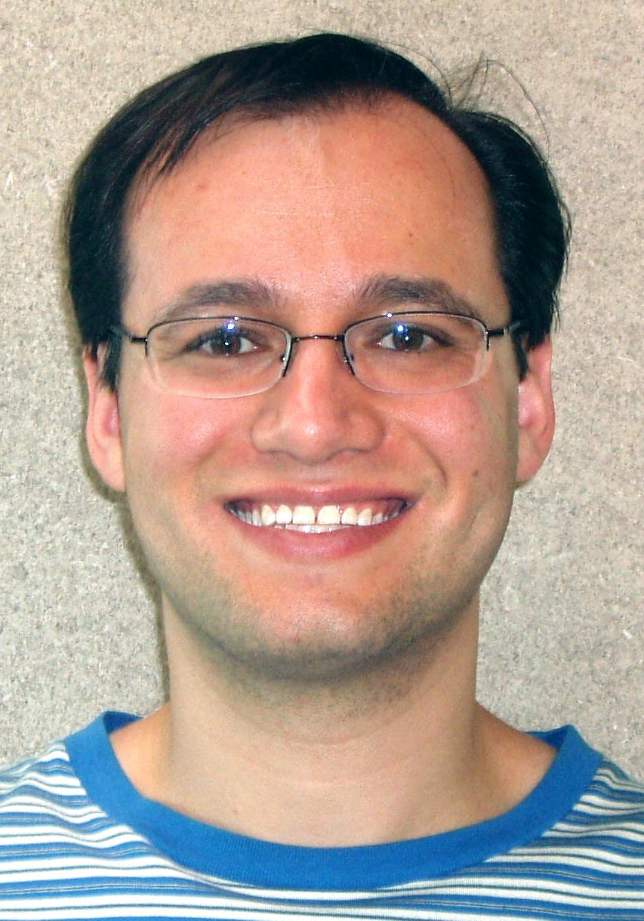  Adam Brody  MLIS | Two New Librarians Launched From Squirrel Hill  Adam Brody and Erin Scioli have brand new Masters degrees! Both studied to become librarians while working full time at our branch. Erin came to Squirrel Hill as a Library Assistant in 2000. She studied online at Clarion University with help from a Laura Bush 21st Century Librarians Grant and graduated in December. Erin became the Children and Teen Librarian at the Brookline Library – CLP on June 6. Adam, | 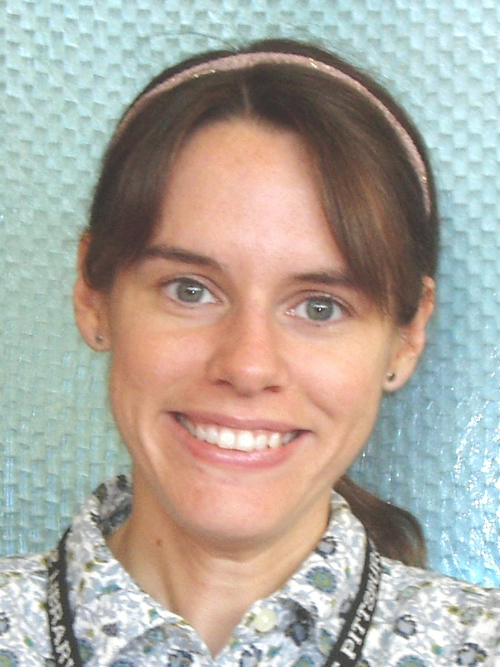  Erin Scioli,  MLS
now a Sr. Clerk, began here as a page in 1998. He graduated from Pitt’s School of Library and Information Science in May and is looking forward to a job as a Children’s, Business, or General Reference librarian.
BOOKS, BOOKS, BOOKS, BOOKS, BOOKS, BOOKS, BOOKS, BOOKS  We earned more than $4,000 for the library at our Spring Cleanup sale in April– twice what we made in 2010! We hope our July sale (see page 6) will follow suit.  Our used book sales have been doing very well, allowing us to buy many items the CLP budget couldn’t cover. In June we were also able to make a $10,000 contribution to the Our Library, Our Future campaign, to help defray the expenses of that voter initiative. We hope our investment in the future of the CLP will spur other Friends groups, organizations, and individuals to do the same. |   by Margie Spenser  Book Sale Committee
The petition to get our referendum on the November ballot includes the text of the question: "Shall a 0.25 mills special tax, which would be equivalent to $25 per year or $2.09 per month on $100,000 of assessed value, be imposed by the City of Pittsburgh on all taxable real estate in the City of Pittsburgh effective January 1, 2012 and thereafter, the proceeds of which shall be allocated and used only for the maintenance and operation of the Carnegie Library of Pittsburgh?"

Congratulations to our two new librarians! I tell everybody that librarians are the nicest people I know; Erin and Adam certainly bear that out. Science fiction author Spider Robinson tells another side of the story in The Callahan Touch: “Librarians are the secret masters of the universe. They control information. Never p*** one off.” Erin Scioli is now a Master of Library Science and Adam Brody is a Master of Library and Information Science. I betcha they know lots and lots o’ stuff…or at least, where to find it!

This issue of the newsletter presents the first in a series of articles about the interesting groups that use our building as a gathering place. We’re beginning with one of the oldest, PARSEC. They have an impressive list of activities that reach out far beyond western Pennsylvania. I invite the leaders of other groups to email me at margie@pittsburghusedbooks.com. Let’s show everybody how many ways the library affects the community!

PARSEC: HUH? WHO? WHAT?*
What’s Going On Here?
by past president Eric Leif Davin

We are Western Pennsylvania's only fantasy and science fiction club and have been in existence for almost 30 years.
We meet in the Squirrel Hill Carnegie Library the second Saturday afternoon of each month, except August (when we have a picnic) and December (when we have a Christmas party).
Each monthly meeting features speakers, video presentations, or discussions of various topics, such as “Science Fiction Movies of the Fifties”, “Teaching Science Fiction”, or “Filking” (songs with fantasy or science fiction themes).
The February meeting is devoted to "Artists' Show and Tell" by our multi-talented members. The March meeting is devoted to our "in-house" book sale as members sell and exchange titles from their personal libraries.

We sponsor an annual regional science fiction convention, Confluence, each July. Guests of Honor are always top names in the field of fantasy and science fiction. This year’s Guest of Honor is author Robert J. Sawyer.

In conjunction with Confluence, we also sponsor an annual week-long series of workshops, "Alpha Writers," for young
writers attending from all across the nation.

We also sponsor a yearly anthology of short fiction, "Triangulations," which is open to everyone, member or not. The anthology can be found and purchased at Lulu.com.
Our annual short story contest -- cash prizes for the top three, with publication in the Confluence program for the First Place winner – is open to submissions from anyone and past winners have come from around the world.
Our monthly newsletter, "Sigma," goes out to 200 members. Membership is $15 a year.
Membership is open to all. Just drop by our meeting in the Squirrel Hill Library the second Saturday of any month from noon to 5 pm.
*From Wikipedia: The parsec (symbol: pc) is a unit of length used in astronomy. It is about 3.26 light-years, or just under 31
trillion (3.1×10¹³) kilometres (about 19 trillion miles).

We also sponsor a yearly anthology of short fiction, "Triangulations," which is open to everyone, member or not. The anthology can be found and purchased at Lulu.com.
Our annual short story contest -- cash prizes for the top three, with publication in the Confluence program for the First Place winner – is open to submissions from anyone and past winners have come from around the world.
Our monthly newsletter, "Sigma," goes out to 200 members. Membership is $15 a year.
Membership is open to all who have an interest in fantasy or science fiction. Just drop by our meeting in the Squirrel Hill Library the second Saturday of any month from noon to 5 pm.

CARNEGIE LIBRARY OF  PITTSBURGH – SQUIRREL HILL 5801 Forbes Avenue  Pittsburgh, PA 15217  Adult Services: 412-422-9650  Children's Services: 412-422-9841  Fax: 412-422-5811  www.carnegielibrary.org/clp/sq  Is your Friends Membership up to date? Please check your mailing label/membership card. ➔  If the date is before 07/11, you need to renew. Mail us the form below. | ADDRESS SERVICE REQUESTED  your donation is tax deductible as a charitable contribution | 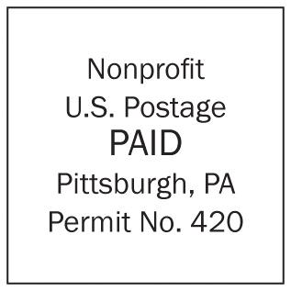  This will be the last issue  sent to anyone whose  membership expired in  2009. Last chance to renew!
  
  «exptext»  «expdate» | «first» «last»  «addr»  Pittsburgh, PA «zip» «zip2»

July 2011 Among Friends Volume V, No. 3

make checks payable to:  Friends of the Squirrel Hill Library  and mail to:  Allison Marciszyn  1914 Murray Avenue #24  Pittsburgh, PA 15217  Check one box:  New Member Renewal  Check one OR two boxes:  $5.00 $10.00 $15.00  $25.00 Other___ DONOR (free  for first year)  Name: _____________________________________  ^{(Last)} ^{(First)}  Address: ___________________________________  City/State: ___________________Zip: ___________  Phone(s): ___________________Date: ___________  E-mail address: ______________________________  Please check all activities you can help with:  Periodic Book Sales Sorting Used Books  Adopt-a-Shelf Program Gardening  Library Advocacy Newsletter/  (lobbying, writing letters) Mailings  COMMENTS_________________________  _____________________________ ___ | 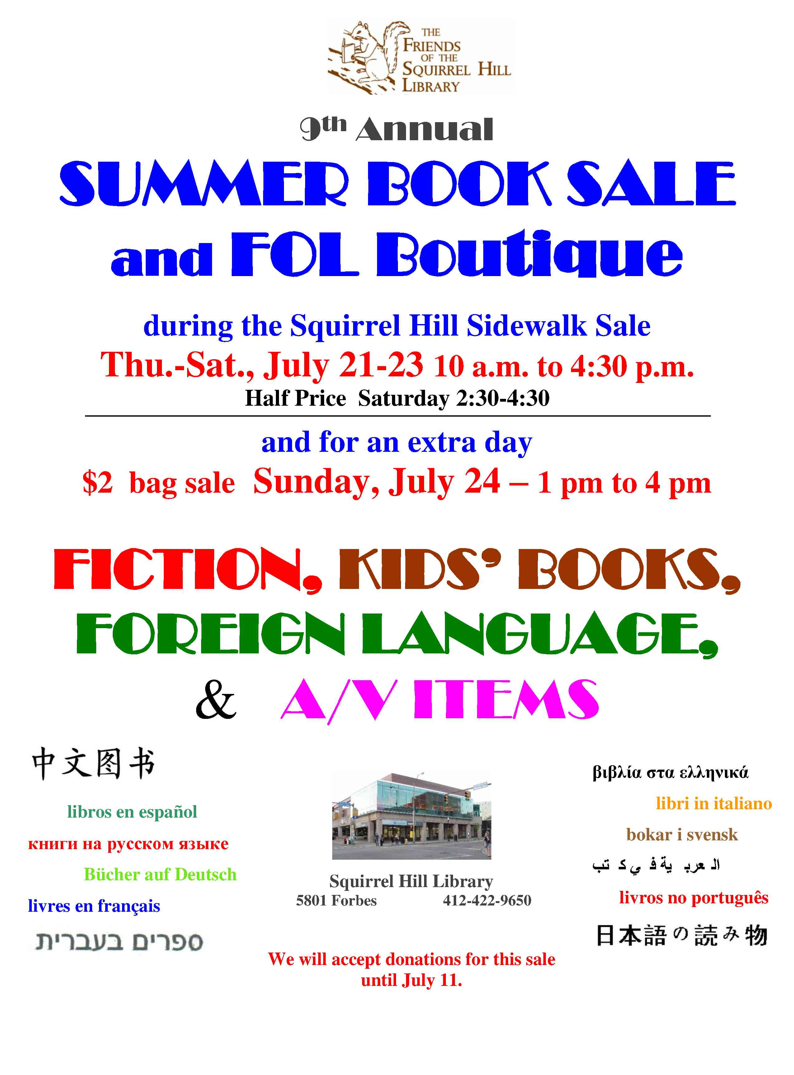  For those with ears to hear, libraries are really noisy places. On their shelves we hear the captured voices of the centuries, old conversation that  makes up our civilization.  Timothy Healy | 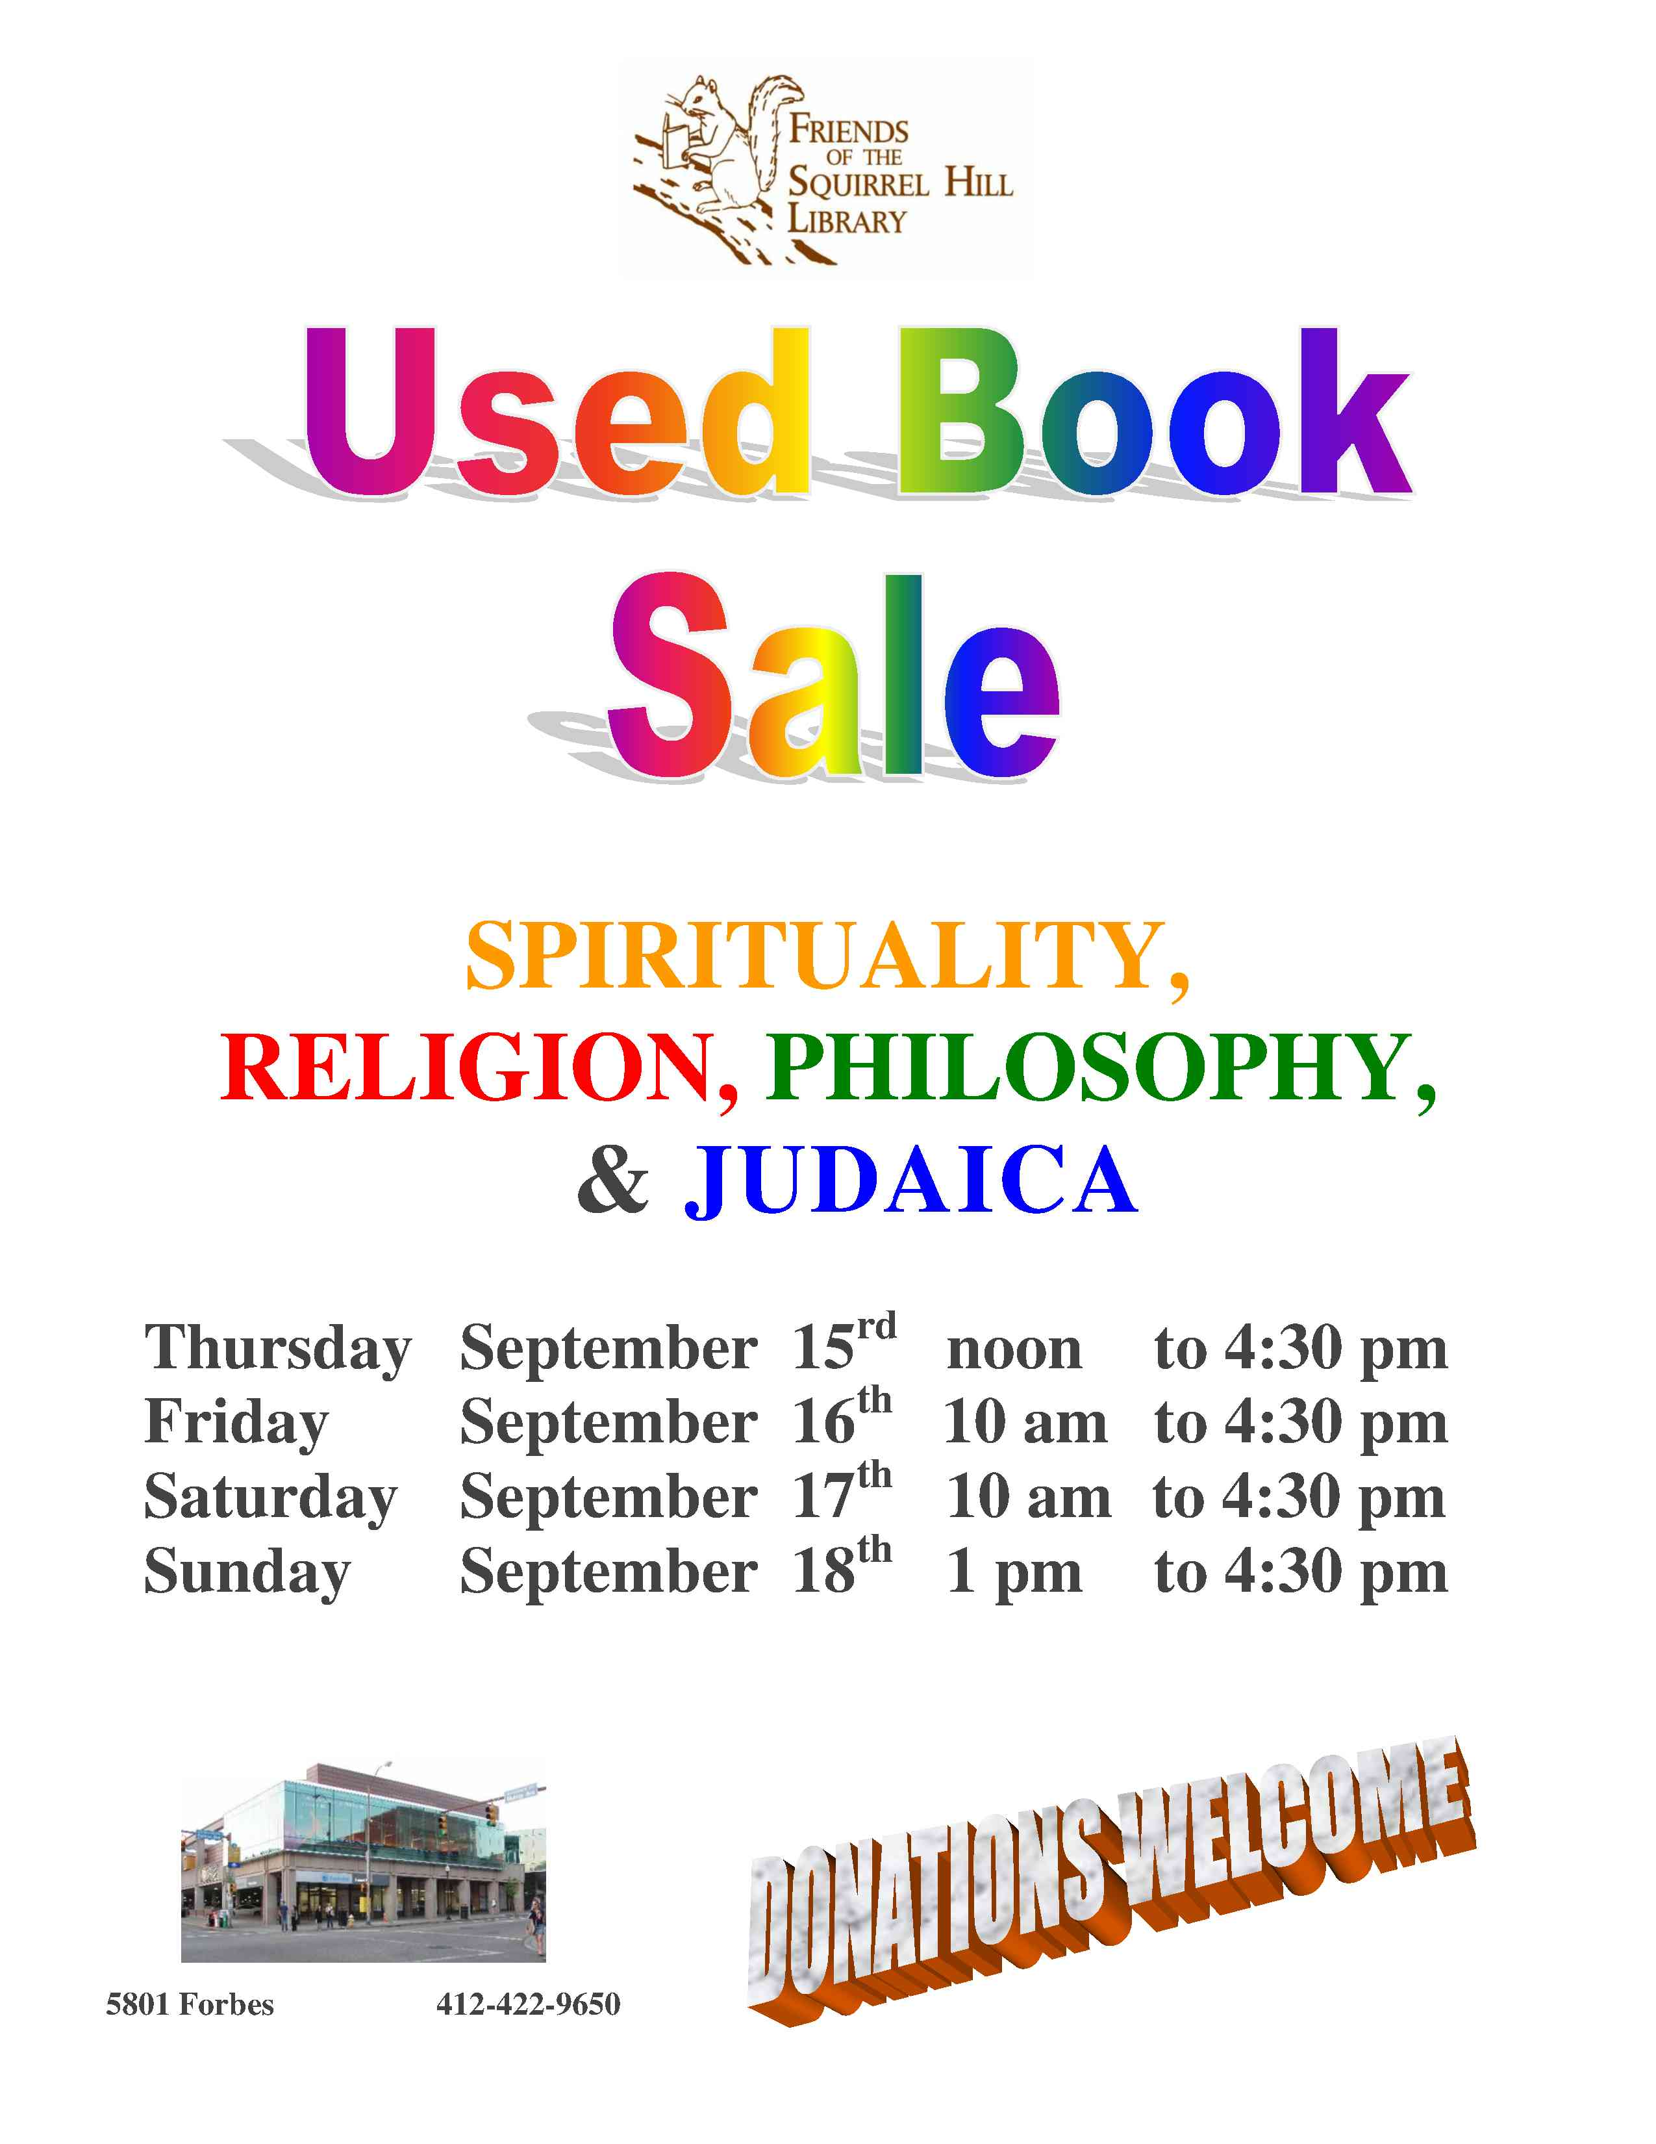  Friends Officers  Joan Schwartzman President  Marilyn Honigsberg Vice President  Eleanor Hershberg Treasurer  Rita Motor Secretary  write us at friends@pittsburghusedbooks.comm

